Code Optimization Test Results

# Emitter Duration = 130 ms (PC)

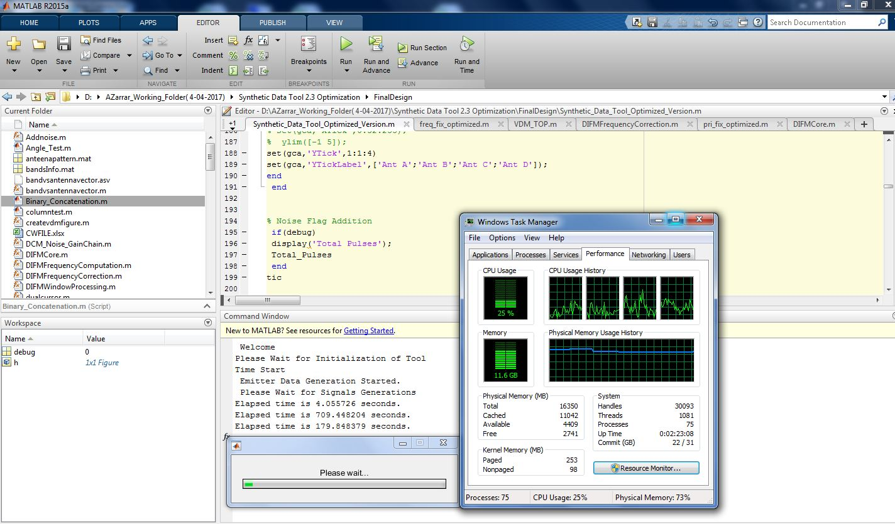

|  |  |
| --- | --- |
| Signal generation time + Volts to mW conversion time + Band filtering + Antenna filtering time + 150 MHz filter implementation time | 709.44 seconds (11.82 mins) |
|  |  |
| mW to Volts conversion + Noise addition + Composite blanking + Carrier and carrier delay conversion to ADC bits time | 179.84 seconds (2.99 mins) |
|  |  |
| VDM time | 40 ~ 50 mins |

# Emitter Duration = 150 ms (PC)

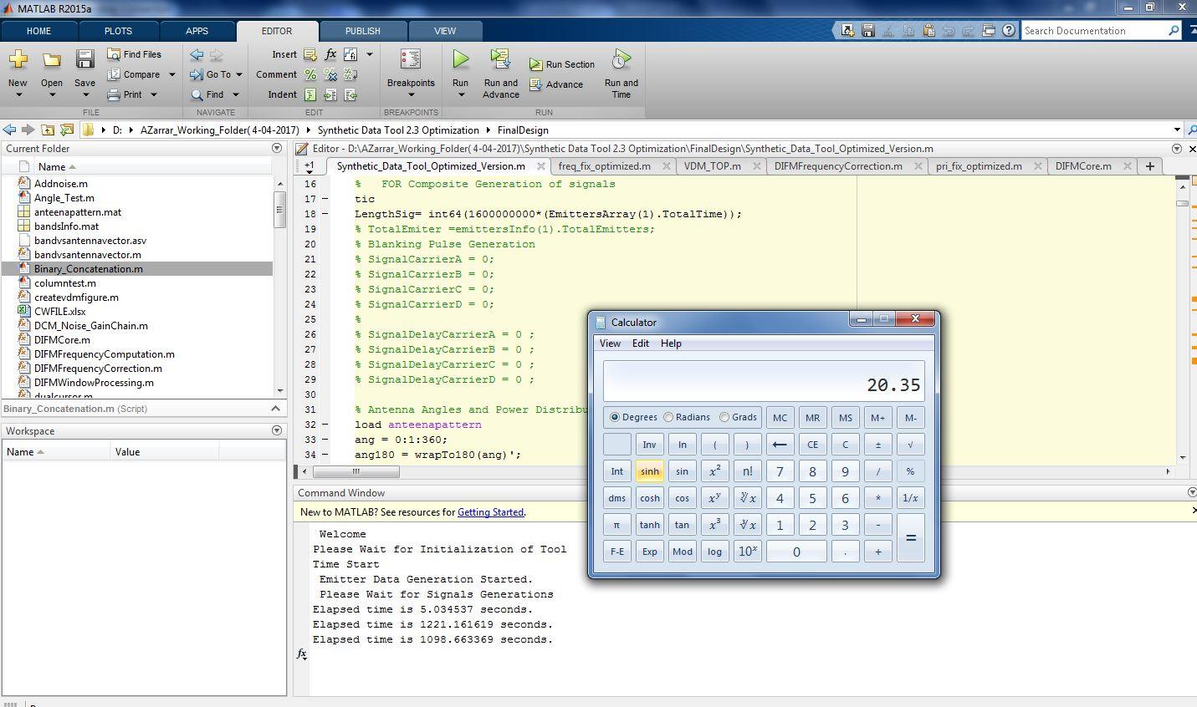

|  |  |
| --- | --- |
| Signal generation time + Volts to mW conversion time + Band filtering + Antenna filtering time + 150 MHz filter implementation time | 1221.14 seconds (20.35 mins) |
|  |  |
| mW to Volts conversion + Noise addition + Composite blanking + Carrier and carrier delay conversion to ADC bits time | 1098.64 seconds (18.31 mins) |
|  |  |
| VDM time | 45 ~ 55 mins |

# Emitter Duration = 1 sec (Server)

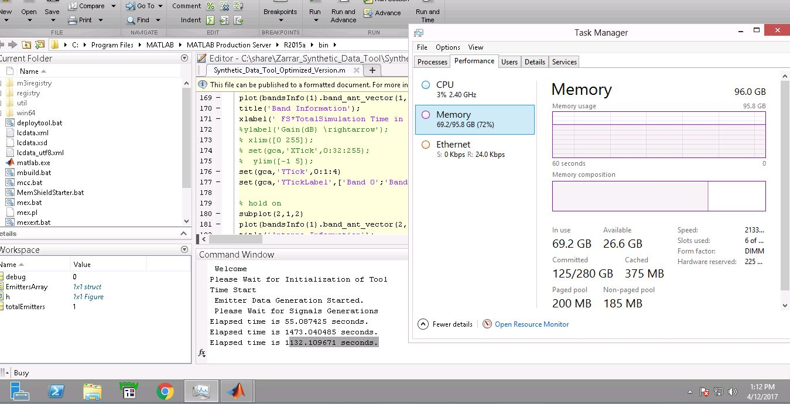

|  |  |
| --- | --- |
| Signal generation time + Volts to mW conversion time + Band filtering + Antenna filtering time + 150 MHz filter implementation time | 1473.04 seconds (24.55 mins) |
|  |  |
| mW to Volts conversion + Noise addition + Composite blanking + Carrier and carrier delay conversion to ADC bits time | 1132.11 seconds (18.87 mins) |
|  |  |
| VDM time | Not Tested |

# Emitter Duration = 1.5 sec (Server)

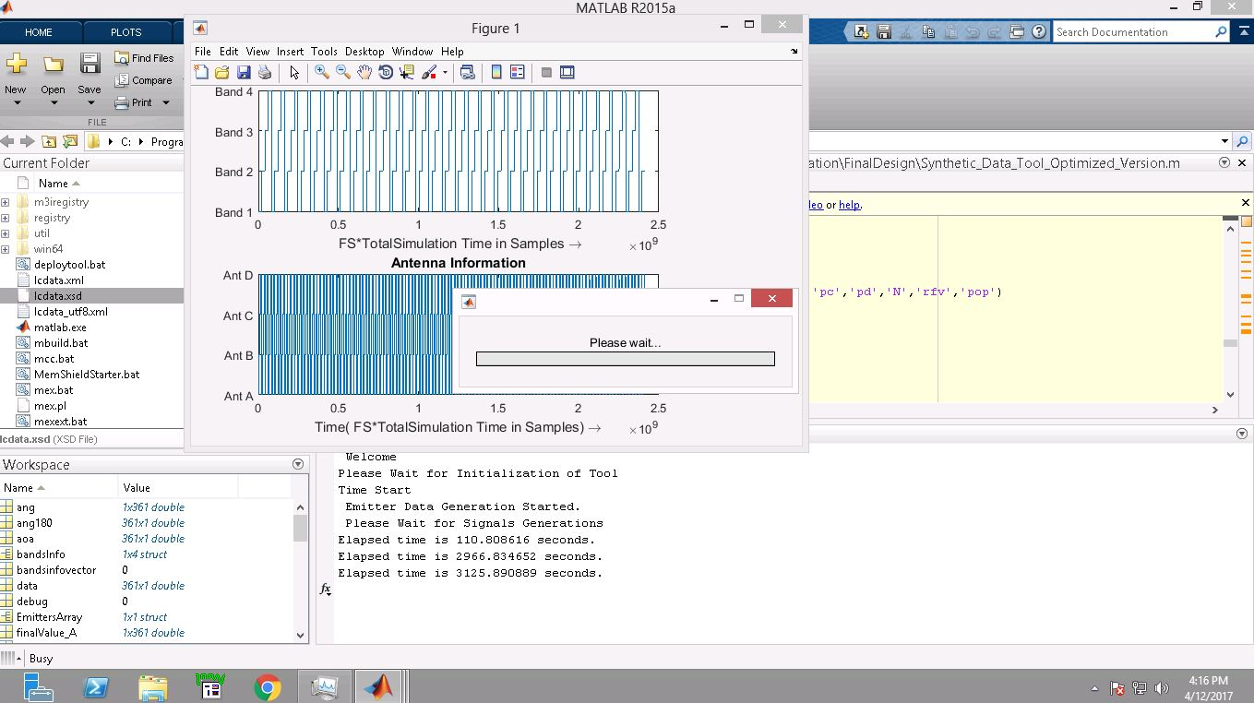

|  |  |
| --- | --- |
| Signal generation time + Volts to mW conversion time + Band filtering + Antenna filtering time + 150 MHz filter implementation time | 2966.83 seconds (49.44 mins) |
|  |  |
| mW to Volts conversion + Noise addition + Composite blanking + Carrier and carrier delay conversion to ADC bits time | 3125.89 seconds (52.09 mins) |
|  |  |
| VDM time | Not Tested |